**International conference**

# “Professional training in sustainable forest management in Austria, Slovenia and Croatia: Experiences, lessons learnt and

# looking ahead”

8 June 2018

Hotel Panorama, Zagreb, Croatia

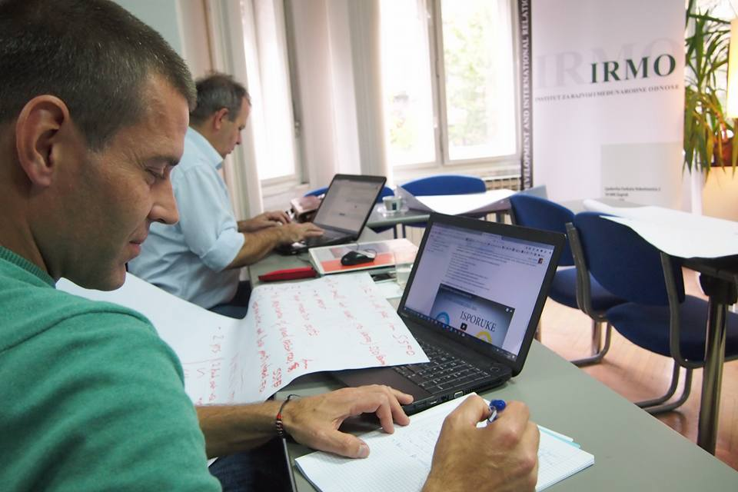

# About CIA2SFM project

The conference „**Professional training in sustainable forest management in Austria, Slovenia and Croatia: experiences, lessons learnt and looking ahead**“ is the final event of the Erasmus+ project Cooperation for innovative approach in sustainable forest management training ([CIA2SFM](http://www.cia2sfm.org/)). The aim of the conference is to present project results, share the experiences and lessons learnt as well as to present plans for the CIA2SFM project's sustainability. The conference will bring together partner organizations, trainers, as well as project’s target groups.

The main objective of the CIA2SFM project is to increase the labor market relevance of vocational education and training (VET) and fostering access to quality VET by development of innovative curriculum and e-learning course on sustainable forest management for project’s target groups. Project target groups are forestry professionals, private forest owners, forestry entrepreneurs and employees of institutions in charge of protected areas management.

***Hereby you can find practicalities with all the necessary information on the venue, participants, registration, programme and many others. For further questions, please contact local contact points (information is provided at the end of this document).***

Agenda of the conference (tentative)

|  |  |
| --- | --- |
| The conference programme, 8/6/2018, hotel Panorama, Zagreb | |
| 09:00-10:00 | **Registration and welcome coffee break** |
| 10:00- 10:15 | **Welcome speeches** |
| 10:15-10:35 | **General about the Erasmus + programme and its implementation in Croatia**  Branka Radonić Choudhury, AMPEU, Croatia |
| 10:35-10:50 | **General information about the CIA2SFM project**  Silvija Krajter Ostoić, Croatian Forest Research Institute |
| 10:50-11:05 | **Importance of VET and LLL**  Irena Ištvanić, ASOO, Croatia |
| 11:05-11:25 | **Keynote speech 1 – Key Challenges in Forestry**  Andrej Breznikar, Slovenia Forest Service, Slovenia |
| 11:25-12:00 | **Coffee break** |
| 12:00-12:20 | **Examples of good practice in forestry related VET and LLL from Austria, Slovenia and Croatia**  Patrick Huber, BOKU, Austria  Boris Rantaša, Slovenia Forest Service, Slovenia  Maja Pleše, Advisory Service, Croatia |
| 12:20-12:40 | **E-learning in forestry- pros and cons**  Johann Zöscher; Forestry Training Centre Ossiach, BFW, Austria |
| 12:40-13:00 | **Presentation of the curriculum and the training programme “Sustainable forest management: from theory to practice”**  Marta Curman, Croatian Forest Research Institute |
| 13:00-13:20 | **Sharing experiences about piloting the training programme**  Andreas Zitek, BOKU, Austria |
| 13:20-13:40 | **Evaluation of the implemented training programme**  Karolina Horvatinčić, IRMO, Croatia  Miljenko Županić, Croatian Forest Research Institute, Croatia  Boris Rantaša, Slovenia Forest Service, Slovenia  Darja Kocjan, Slovenian Forestry Institute, Slovenia |
| 13:40-14:00 | **Panel discussion/round table**  moderator Andrej Breznikar, Slovenia Forest Service, Slovenia |
| 14:00 | **End of the formal part of the agenda** |
| 14:00-15:30 | **Lunch** |
| 15:30 | **Farewell to participants** |

**Conference participants**

Besides employees of project’s partner organisations, targeted audience includes project’s target groups (forestry professionals, private forest owners, forestry entrepreneurs and employees of institutions in charge of protected areas management). **Participation in this event is free of charge.** Link for registration is here.

Project partners:

* Croatian Forest Research Institute (project coordinator, CRO)
* Institute for Development and International Relations (IRMO, CRO)
* Slovenia Forest Service (SFS, SLO)
* Slovenian Forestry Institute (SFI, SLO)
* Slovenian Institute for adult education (SIAE, SLO)
* University of Natural Resources and Life Sciences (BOKU, AUT)
* Austrian Research Centre for Forests (BFW, AUT)

**Venue**

**Panorama Zagreb Hotel, Zagreb, Croatia**

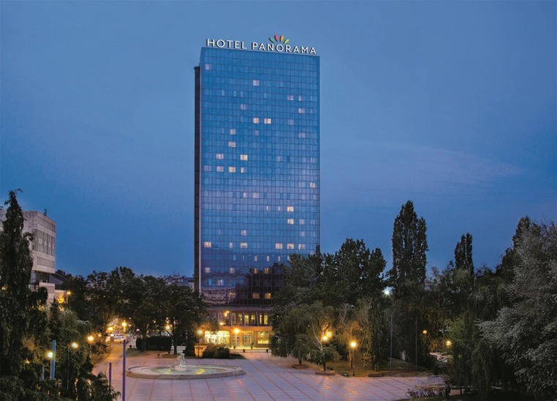

**ADDRESS:**

Trg Krešimira Ćosića 9, 10 000 Zagreb

**GPS:**

45.8056764095219

15.9527647018433

**Travel costs**

Participants’ travel costs will be covered by the ERASMUS+ CIA2SFM project. Participants are kindly asked not to buy tickets themselves since in that case we would not be able to make the reimbursement. After the registration please contact your local contact points.

**How to reach the venue**

Panorama Zagreb is located in the Trešnjevka neighborhood, close to the sports hall Dom Sportova, a central place for numerous sports and cultural events.

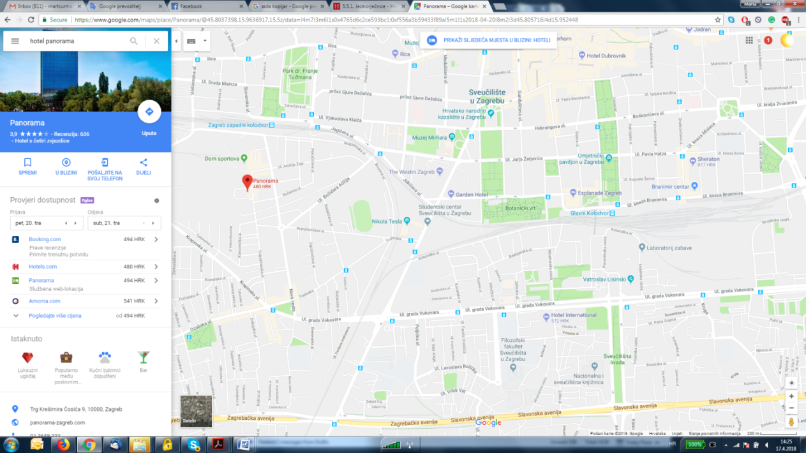

**Public transportation in the city of Zagreb**  
The hotel is situated across from the sports hall Dom Sportova. **Tram lines 3, 9 and 12** bring you to the hotel. Get off at the Trešnjevački Square tram stop. More information on public transportation in the city of Zagreb is available [here](http://www.zet.hr/).

**Railway**  
If you are travelling by train, take the tram line 9 (direction west, towards Ljubljanica) from the Central Railway Station. Get off at the 4th stop (Trešnjevački Square). Then walk for 5-10 minutes north.

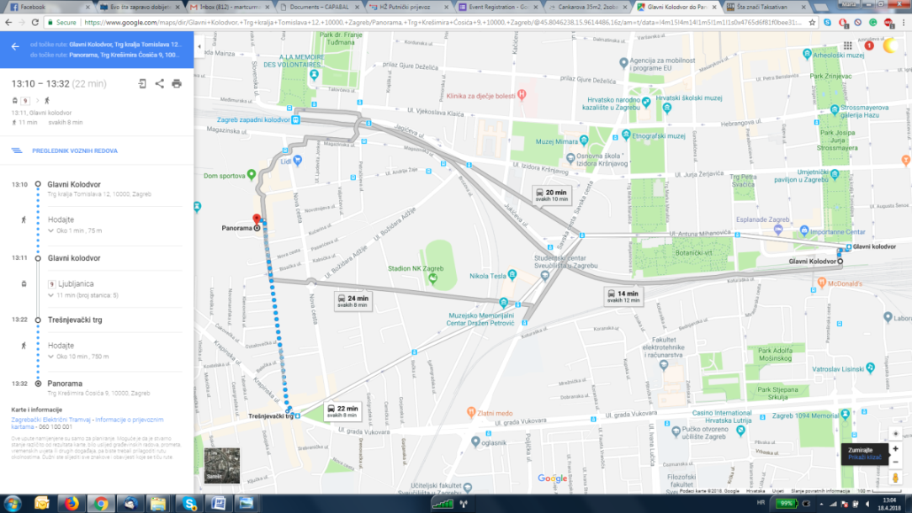

**Taxi options**

**Uber –** 20-30 HRK from Central Railway/Bus Station to the hotel

**Taxi Zagreb –** tel. +385 1 1717, 10 HRK start and 6 HRK/km

**Cammeo** – tel. +385 1 1212, 6 HRK start and 6 HRK/km

Other option from the Central Railway Station is by train. You can choose trains toward Zaprešić, Harmica and Zabok/Varaždin (direction west). Get off at the 1st stop (Zapadni kolodvor). The hotel is situated to the south of the train station, walking distance around

up to 10 minutes.

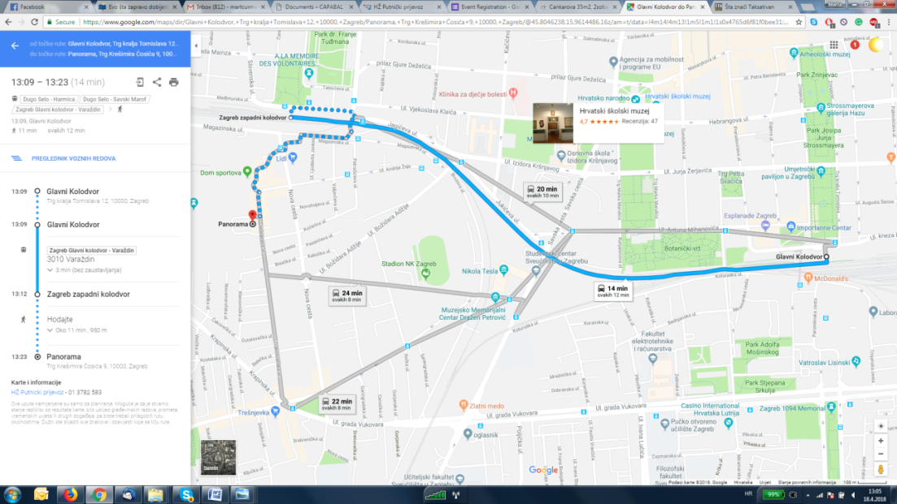

**Central Bus Station**  
From the Central Bus Station take the tram to the Central Railway Station (direction Črnomerec, tram lines 2 or 6). Get off at the 3rd stop. Then take the tram line 9 (direction Ljubljanica). Get off at the 4th stop (Trešnjevački Square). The hotel is situated to the north of the square, walking distance 5-10 minutes. For more information look at the **Railway**.

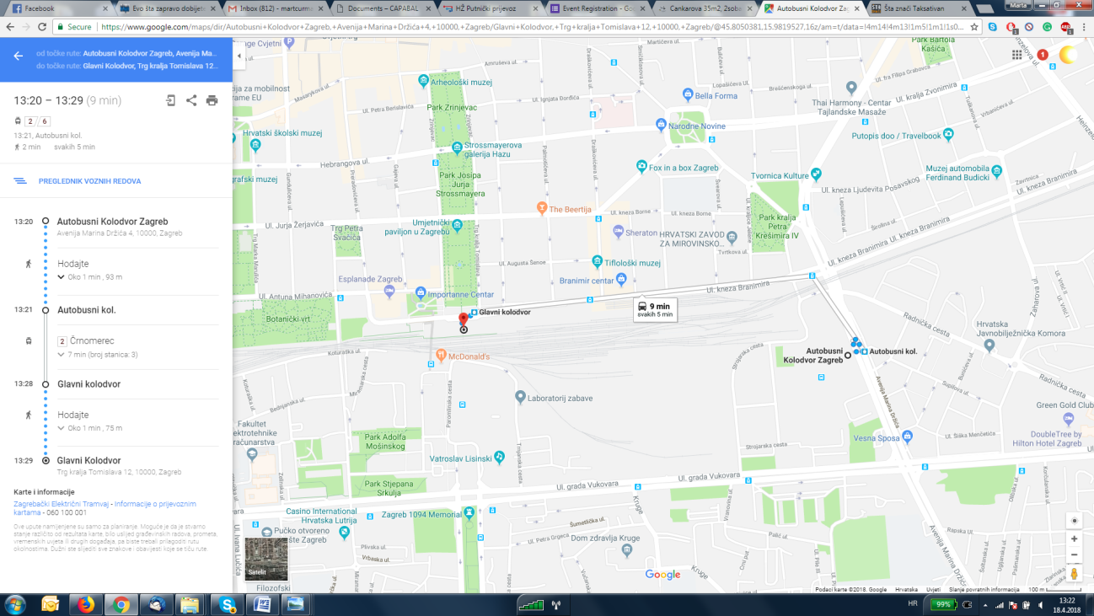

**By car**  
From the WestIf you are coming from the West (highway A2, Bregana border crossing, Slovenia) take the Zagreb West exit. Continue driving along on Zagrebačka Avenue (9 km), then turn left on Savska Street and follow the signs for Panorama Zagreb.  
From the SouthIf you are on highway A1 towards Zagreb, after the toll station continue on Jadranska Avenue until you get to the roundabout. Take the 3rd exit on the roundabout and continue driving on Jadranski Bridge. At the first traffic lights, turn right on Savska Street and continue driving towards the city centre following the signs for Panorama Zagreb.  
The hotel has an open parking lot for the hotel guests.

From the EastIf you are coming from the East (highway A5 - Slavonia), after the toll station, drive straight down on Slavonska Avenue until you get to the centre, then turn right on Savska Street and follow the signs for Panorama Zagreb.

**Accommodation**

In case when participants are not able to travel to and from the conference on the same day accommodation will be provided in the Hotel Panorama in single or double rooms. Costs will be covered by the CIA2SFM project.

**Meals and Snacks**

During the event participants will be provided with two coffee breaks and a lunch.

**Welcome coffee break** is planned prior the conference, from 9:00-10:00 and the **second coffee break** with snacks is planned from 11.30-12:00.

**The lunch** is planned after the conference ends, around 14:00.

**Language of the conference**

Since the event will include participants from Austria, Croatia and Slovenia, language of the conference will be English with simultaneous interpretation into Croatian.

**Weather info for Zagreb**

<http://meteo.hr/> (in Croatian)

<http://prognoza.hr/prognoze_e.php?id=zgdanas_e> (in English)

**Tourist information**

<http://www.infozagreb.hr/>

**Important numbers**

Emergency services (police, fire department, emergency): 112

Hotel Panorama: +385 1 3658 333

Contacts

Croatia:

**Marta Curman**

[martac@sumins.hr](mailto:martac@sumins.hr)

**Tel.: +385 98 942 5026**

**Silvija Krajter Ostoić**

[silvijak@sumins.hr](mailto:zupanicm@sumins.hr)

Slovenia:

**Boris Rantaša**

[boris.rantasa@zgs.si](mailto:boris.rantasa@zgs.si)

**Darja Kocjan**

[darja.kocjan@gozdis.si](mailto:darja.kocjan@gozdis.si)

**Tel: +386 31 841 339**

Austria:

**Patrick Huber**

[patrick.huber@boku.ac.at](mailto:patrick.huber@boku.ac.at)

**Tel.:** **+43 (1) 47654-19713**

**Robert Jandl**

[robert.jandl@bfw.gv.at](mailto:robert.jandl@bfw.gv.at)

**Tel.:+43 (1) 87838 1120**